H.T No
Regulations:
A15

Sreenidhi Institute of Science and Technology
(An Autonomous Institution)
Code No: 5AC07 Date: 01-July-2021(AN)

B.Tech IV-Year I- Semester Pending External Examination, July - 2021 (Supplementary)
CONTROL SYSTEMS (ECE)

Time: 3 Hours Max.Marks:75

Note: a) No additional answer sheets will be provided.
b) All sub-parts of a question must be answered at one place only, otherwise it will not be valued.
c) Missing data can be assumed suitably.

ANSWER ANY 5 OUT OF 8 QUESTIONS. EACH QUESTION CARRIES 15 MARKS.

Bloom's Cognitive Levels of Learning (BCLL)

Remember | L1 | Apply | L3 | Evaluate | L5
Understand | L2 | Analyze | L4 | Create | L6

 |  |  | BCLL | CO(s) | Marks
1. | a) | Explain open loop control system and closed loop control system with example. | L2 | CO1 | [8M]
 | b) | Find the transfer function for the Mechanical translation system shown in figure.  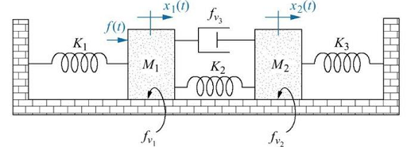 | L2 | CO1 | [7M]
2. | a) | Write the equations for time domain specifications of a standard second order system with unit step input? | L1 | CO2 | [8M]
 | b) | A unity feedback system with closed loop transfer function is Show that the steady state error with unit ramp input is . | L3 | CO2 | [7M]
3. | a) | Construct Routh array, determine stability and find the location of roots for the systems represented by the following characteristic equation. | L3 | CO3 | [8M]
 | b) | List all the rules to construct a root locus and explain. | L1 | CO3 | [7M]
4. | a) | List the advantages and limitations of Frequency response methods. | L1 | CO4 | [8M]
 | b) | Draw the bode plot for a system having  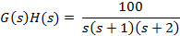  Find  (i) Gain margin (ii) phase margin | L3 | CO4 | [7M]
5. | a) | Sketch the direct polar plot for a unity feedback system with open loop transfer function.  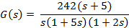 | L3 | CO5 | [8M]
 | b) | Explain the procedure for the design of Lag – lead compensator. | L2 | CO5 | [7M]
6. | a) | List the properties of State transition matrix. | L1 | CO6 | [8M]
 | b) | Determine the state model of the system for the following transfer function  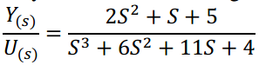 | L3 | CO6 | [7M]
7. | a) | Compare block diagram and signal flow graph methods. | L3 | CO1 | [5M]
 | b) | Show that with derivative controller, the damping ratio and steady state error increases. | L3 | CO2 | [5M]
 | c) | List the Limitations of Routh Criterion. | L1 | CO3 | [5M]
8. | a) | List the advantages and limitations of Frequency response methods. | L1 | CO4 | [5M]
 | b) | State and Briefly Explain Nyquist stability criterion. | L2 | CO5 | [5M]
 | c) | Explain various methods of evaluation of state transition matrix. | L2 | CO6 | [5M]

-- 00 -- 00 –

